

THE INFLUENCE OF LIGHT ON SOIL MICROBIAL COMMUNITY STRUCTURE AND CONSEQUENCES FOR SOIL COS EXCHANGE

**Clément Foucault**

*Master 2 Biodiversité et Fonctionnement des Ecosystèmes Terrestres*

University year 2019-2020

Thesis defended on 23/06/20

University of Bordeaux

**Supervisors:**

Lisa Wingate (lisa.wingate@inrae.fr)

Nicolas FANIN (nicolas.fanin@inrae.fr)



**Host Laboratory:**

INRAE-ISPA

71 Avenue Edouard Bourlaux,

33140 Villenave-d'Ornon

Table of contents :

Introduction : 1

Material and Methods : 3

Experimental and soil sampling : 3

Gas exchange experimental setup : 4

Soil community analysis : 5

Statistical analyses : 5

Results : 6

COS and CO2 balance across soil types and light treatments 7

Effect of soil types and light treatments on microbial communities 7

Linking microbial communities to COS fluxes and soil physicochemical properties 10

Effect of microbial OTUs on COS balance 11

Microbial interactions network 13

Discussion : 14

Effect of light on photoautotroph community composition 15

Effect of photoautotroph community composition on heterotroph communities 16

Links between microbial OTUs and COS fluxes 17

Conclusion 18

References 18

Supplementary material 20

# Introduction :

Carbonyl sulfide (COS) is the most abundant sulphur bearing gas in the atmosphere, with a mean worldwide concentration of about 0.5 ppb (Sandalls & Penkett, 1977). Monitoring of atmospheric concentrations at the global scale reveals that COS concentrations decrease during the photosynthetic season (Montzka et al., 2007). Indeed, COS molecules follow similar diffusive and enzymatic pathways to those of carbon dioxide (CO2) especially into leaves during photosynthesis, where both molecules are metabolised by the enzymes RUBISCO and PEPC. Another enzyme, carbonic anhydrase (CA), also strengthens this uptake process since it catalyses both the reversible hydration of CO2 and the irreversible hydrolysis of COS (Protoschill-Krebs et al., 1996). This makes COS a great proxy to estimate gross primary production (GPP) independently at the ecosystem (Campbell et al., 2008) and global scale (Campbell et al., 2017). An advantage of COS over CO2 measurements is the absence of COS emissions from leaves of vascular plants, that leads to a unidirectional flux that is expected to scale with the ecosystem photosynthetic activity (Berry et al., 2013). However, this method can only be applied if it is assumed that plants contribute to the major part of terrestrial COS fluxes. Yet many soil organisms are capable of consuming atmospheric COS (Kesselmeier et al., 1999), thereby influencing COS fluxes at the ecosystem scale. Therefore, it is necessary to evaluate the impact of soil organisms on atmospheric COS concentrations to improve predictions of soil COS flux variability spatially and temporally.

Soil organisms such as bacteria and fungi are major regulators of COS fluxes (Kesselmeier et al., 1999; Sauze et al., 2017). They are able to consume COS through their CA activity, which plays an important role in carbon fixation and sulfur metabolism (Smith et al., 1999; Ogawa et al., 2013). For example, Ogawa et al. (2013) have shown that *Thiobacillus thioparus* can grow on thiocyanate (SCN-) by converting it first into COS, which can then be processed and consumed through CA activity. Soil microbial communities and CA activity are themselves controlled by many environmental parameters. For instance, a recent study by Sauze et al. (2017) highlighted the importance of pH in soil COS fluxes, probably through both indirect community shaping effects and its direct influence on the enzyme kinetics. Soil water content and temperature can also influence COS uptake, through their effect on COS diffusion efficiency in soils and on CA activity (Kesselmeier et al., 1999; Ogée et al., 2016). All together, these data suggest that environmental variables and soil physicochemical properties may be important drivers controlling both soil microbial community composition and COS fluxes, from the local to the global scale (Meredith et al., 2019). However, all these factors may also depend on light conditions, that vary during the day but also according to the environmental context (e.g., across biomes, land use types). Yet, the direct and indirect effects of light on soil organisms have rarely been investigated, and its influence on COS uptake remain largely unknown.

Light was shown as a primary factor impacting COS fluxes in aquatic ecosystems (Blezinger et al., 2000), mainly through its positive influence on the growth and activity of photoautotrophic organisms (Rhee & Gotham, 1981). Photoautotrophs can take up COS through the same chemical pathways as terrestrial plants, with CA catalysing the reaction (Protoschill‐Krebs et al., 1995). Similar results were observed in a recent study manipulating light conditions on various soil types, notably because light stimulated an increase in photoautotroph abundances (Sauze et al., 2017). The contribution of photoautotrophs to COS fluxes is probably underestimated in terrestrial ecosystems (Meredith et al., 2019), notably because until recently we lacked the high throughput sequencing tools necessary to assess the size and structure of photoautotrophic communities in soils (Sauze et al., 2017; Djemiel et al., 2020). However, the development of universal primers shared amongst photoautotrophic organisms (Sherwood & Presting, 2007) and the development of a new database may now help us to assess the direct effect of light on soil photoautotroph communities (Djemiel et al., 2020). Furthermore, fungi and bacteria may benefit from positive interactions with phototrophs and their photosynthetic products and influence, in turn, COS fluxes in a similar way to that shown in oceans, with bacteria gathering around phytoplankton to form a phycosphere zone (Seymour et al., 2017). Yet, shifts in soil phycosphere communities (i.e., phototrophs, bacteria and fungi) between light and dark conditions have rarely been investigated in the literature and the consequences of their interactions on gas exchange across contrasting soil types remain to be determined (Whelan et al., 2018).

In this study, our main objective was to assess the variability of COS and CO2 fluxes in relation to soil communities (algae, bacteria and fungi) present in soils incubated in dark or light conditions, and to explore how these fluxes are linked to soil microbial community composition. To do so, a lab experiment was implemented that consisted in the incubation of four different soil types that varied strongly in their initial physicochemical properties. The effect of light on soil communities (phototrophs, bacteria and fungi) was assessed by using two photoperiod conditions consisting of either 16 hours of light and 8 hours in the dark, or 24 hours in the dark. By using next-generation sequencing data after forty days of incubation in either the light or the dark treatment, I tried to link soil microbial communities to variations in CO2 and COS. Because the abundance of photoautotrophic organisms (more specifically the number of 23S gene copies) are supposed to increase with light (Sauze et al., 2017), we hypothesised that the composition of phototroph communities would differ tremendously in light-conditions compared with dark-conditions (H1). Specifically, we expected that fast-growing phototrophs that strongly depend on light conditions would increase in the light treatment while stress-tolerant cyanobacteria that are well adapted to shade environments would increase in the dark treatment. These effects should also vary with soil types because many photoautotrophic organisms are heavily affected by low pH levels (Lund, 1947). Second, I tested the hypothesis that shifts in the photoautotrophic community should affect the composition of the heterotrophic microbial community (H2). Specifically, we hypothesised that specific fungal or bacterial classes could benefit from increased algal abundance, such as the Chytridiomycetes which are frequent algal parasites (Ibelings et al., 2004). In addition, copiotrophic organisms (i.e., as opposed to oligotrophic) such as Proteobacteria and Bacteroidetes are also expected to benefit from the synthesis of photosynthates by photoautotrophs in the light (Kaiser et al., 2015). Finally, I tested the hypothesis that changes in the composition of algal and microbial communities would have important repercussions on soil COS fluxes (H3). In particular, based on previous observations, we expected that specific classes of bacteria and fungi such as Actinobacteria (Ogawa et al., 2016), Mortierellomycetes (Kitz et al., 2019; Masaki et al., 2016), Sordariomycetes or Leotiomycetes (Meredith et al., 2019) would be linked to strong variations in COS fluxes. Finally, because the 23S region is general to all photosynthetic organisms, nonvascular plants such as bryophytes that grow on soil surfaces may also contribute to COS consumption as demonstrated in Gimeno et al. (2017).

# Material and Methods :

## Experimental and soil sampling :

Four soils (DBZ, LB, LG, TL) were collected in different locations and across a wide range of pH values (4.6-8.1). Le Bray (LB) is a podzol with an organic and sandy A horizon sampled from an evergreen forest located 20km from Bordeaux in February 2016. Lacage (LG) is a luvisol with a silty loam A horizon sampled from an INRAE experiment field growing a wheat-alfalfa rotation located in Versailles during April 2016. Pierrelaye (DBZ) is a luvisol with a sandy A horizon sampled from an INRAE experimental field growing a corn-wheat rotation located 30km from Paris during December 2015. Finally, Toulenne (TL) is a fluviosol sampled from an INRAE experimental orchard growing cherry and peach trees located 50km from Bordeaux during February 2016. For each soil, three spatially independent samples were collected from the first 10 cm of the soil. They were then blended to obtain a single homogeneous soil sample. This composite sample was then divided evenly in 6 jars each filled with approximately 350-400g of soils. The jars were subsequently sealed with parafilm to limit evaporation and were incubated under controlled conditions for 40 days. Temperature and water holding capacity were kept constant, at respectively 20°C and 80%. Three of the six jars were coated with aluminum foil and kept in the dark for the whole incubation time (dark-conditioning or DC), while the three others were kept under light conditions consisting of 16 hours of light and 8 hours of obscurity, hence recreating an artificial diurnal cycle (light-conditioning or LC). During the incubation, jars were periodically opened twice a week in order to refresh the inside air.

## Gas exchange experimental setup :

Forty days later, the aluminium foil was removed from the three dark-conditioned soils and self-contained thermo-couple dataloggers (iButton, DS1923, Embedded Data Systems, Lawrenceburg, KY, US) were placed inside LC and DC jars to measure humidity and temperature at the soil surface. Jars were then sealed with a customized glass lid, and placed in a customized climate-control chamber to acclimate at 25°C with the lights on. To make sure that the setup didn’t present COS contamination, an additional empty glass jar was also sealed and connected to an array of lines in the climate chamber. During gas exchange measurements, a compressor (FM2 Atlas Copto, Nack, Sweden) was used to provide each microcosm with air. The system was coupled to a chemical scrub column (Ecodry K-MT6, Parker Hannifin, Cleveland, OH, US) to remove water vapour, CO2 and COS from the ambient air in the lab prior to the measurements. To supply the airflow with CO2 and COS, and to achieve concentrations of about 420 ppm of CO2 and 1000 ppt of COS, a set of individual mass flow controllers (MFC, EL-Flow Select, Bronkhorst, Ruurlo, NL) and stainless steel cylinders containing either pure CO2 or COS were connected to the system. The dry air that supplied each microcosm was drawn from this buffer volume at a constant flowrate. The flow between the buffer volume and the microcosms was maintained by a slight overpressure of 20 to 30 mbar above atm.

The air flows from the microcosms were scanned at 1 Hz for 2 minutes with the last 20 seconds used to calculate the mean concentration. The 7 chambers were then scanned sequentially by the COS and CO2 analyzers. In case they were not measured, they were then flushed continuously with a constant flowrate. The entire sequence of gas flow measurements lasted 24 hours and included periods of light and darkness. The first 12 hours of gas exchange were conducted with the lights on, and the next 12 hours in darkness.

## Soil community analysis :

Following the gas flow measurements, samples were taken from the surface of each microcosm and stored in the dark at -80°C before being freeze-dried. Microbial DNA was then extracted from 1g of soil of each triplet of replicates for each light treatment following this procedure previously described (Plassart et al., 2012; Sébastien Terrat et al., 2012). DNA concentrations of the crude extracts were determined by electrophoresis with a 1% agarose gel using a standard calf thymus DNA curve, and were used as estimates of microbial molecular biomass. Following quantification, a PVPP column and a GENECLEAN turbo kit were used to purify the DNA. Abundances of bacteria, fungi and phototrophs (algae, cyanobacteria and bryophytes) were estimated from the number of gene copies measured for 16S, 18S and 23S-rDNA plastids, respectively by qPCR using a StepOne Real-Time PCR System with a SYBRGreen detection system and the primer sets defined previously (Sauze et al., 2017). In order to ensure that the sampling effort was equivalent between each replicate, the number of sequences was rarefied to ? subsequently. A raw data analysis of the 23S plastid rDNA amplicons obtained from the soil samples was performed using the GnS pipeline available at:<https://zenodo.org/record/1123425#.XqmBTagzZPZ> (Terrat et al., 2012) following the different steps described previously (Terrat et al., 2015). Taxonomic identification of the 23S genes was carried out using the μgreen-db database http://microgreen-23sdatabase.ea.inra.fr/ (Djemiel et al., 2020) and the USEARCH program (v6.0.307; ) with specific parameters (-maxhits 15, -maxaccepts 0, and maxrejects 0).www.drive5.com/usearch) with specific parameters (-maxhits 15, -maxaccepts 0, and maxrejects 0).

The resulting material consisted in multiple tables compiling the abundances for each OTU identified. We chose to present and analyze data at the “class” level because this taxonomic level appeared to be the best compromise between being precise enough and being able to compare between kingdoms. Data analyses were also run at lower taxonomic levels, with roughly similar results however, the number of unassigned OTUs generally increased (referred to in the Figures as “unidentified”). Furthermore, information describing the ecology of organisms at the class level was probably the best given that the dissimilarity among microbial functions generally increased at higher trophic levels.

## Statistical analyses :

All statistical analyses were performed with the R software package (R version 3.6, R Core Team, 2019).Permanovas (adonis in vegan package, Oksanen et.al, 2008) allowed an assessment of how soil light treatments (light or dark) and soil types (DBZ, LB, LG or TL) as well as their interaction influenced the composition of bacterial, fungal and phototroph communities. Mixed effect linear models (lme in nlme package, Pinheiro et al., 2015) were used to determine the effect of light treatments and soil type on CO2 and COS soil fluxes. The position in the climate-control chamber was taken as a random effect in these analyses. Canonical correspondence analysis (CCA) was used to represent the variation among algal, bacterial or fungal classes and analyze how much of the total variation (inertia) was explained by the ‘environmental variables’, i.e., measured components of OM quality and soil properties (Ramette, 2007). The environmental variables analysed were land use, pH, sand content, silt content and C:N ratio. We used generalized linear latent variable models (gllvm from the gllvm package, Niku et al., 2019) to explain CO2 and COS fluxes by community composition parameters (i.e., classes of algae, bacteria and fungi). Finally, network plots (igraph package, [Csárdi](https://www.semanticscholar.org/author/G%C3%A1bor-Cs%C3%A1rdi/2545870) et al., 2006) were built using the rarefied number of gene copies either in the dark or in the light. For this last analysis, we selected only the microbial classes significantly involved in COS fluxes, according to the previous generalized linear latent variable model analysis. An abbrevations table for the CCA and the network analysis can be found in the supplementary data.

# Results :

**Table 1** - Characteristics of the four different soil types across treatment

|  |  |  |  |  |  |  |  |
| --- | --- | --- | --- | --- | --- | --- | --- |
| **Soil type** | **Light treatment** | **Land use** | **pH** | **Sand content (g.kg-1)** | **Silt content (g.kg-1)** | **Clay content (g.kg-1)** | **C:N ratio** |
| DBZ | dark | cropland | 7.05 | 822 | 57 | 91 | 13.9 |
| DBZ | light | cropland | 6.85 | 822 | 57 | 91 | 13.9 |
| LB | dark | pine plantation | 4.52 | 947 | 26 | 27 | 26 |
| LB | light | pine plantation | 4.58 | 947 | 26 | 27 | 26 |
| LG | dark | cropland | 6.32 | 184 | 647 | 169 | 10.4 |
| LG | light | cropland | 6.22 | 184 | 647 | 169 | 10.4 |
| TL | dark | orchard | 8.07 | 167 | 523 | 310 | 10.4 |
| TL | light | orchard | 8.13 | 167 | 523 | 310 | 10.4 |

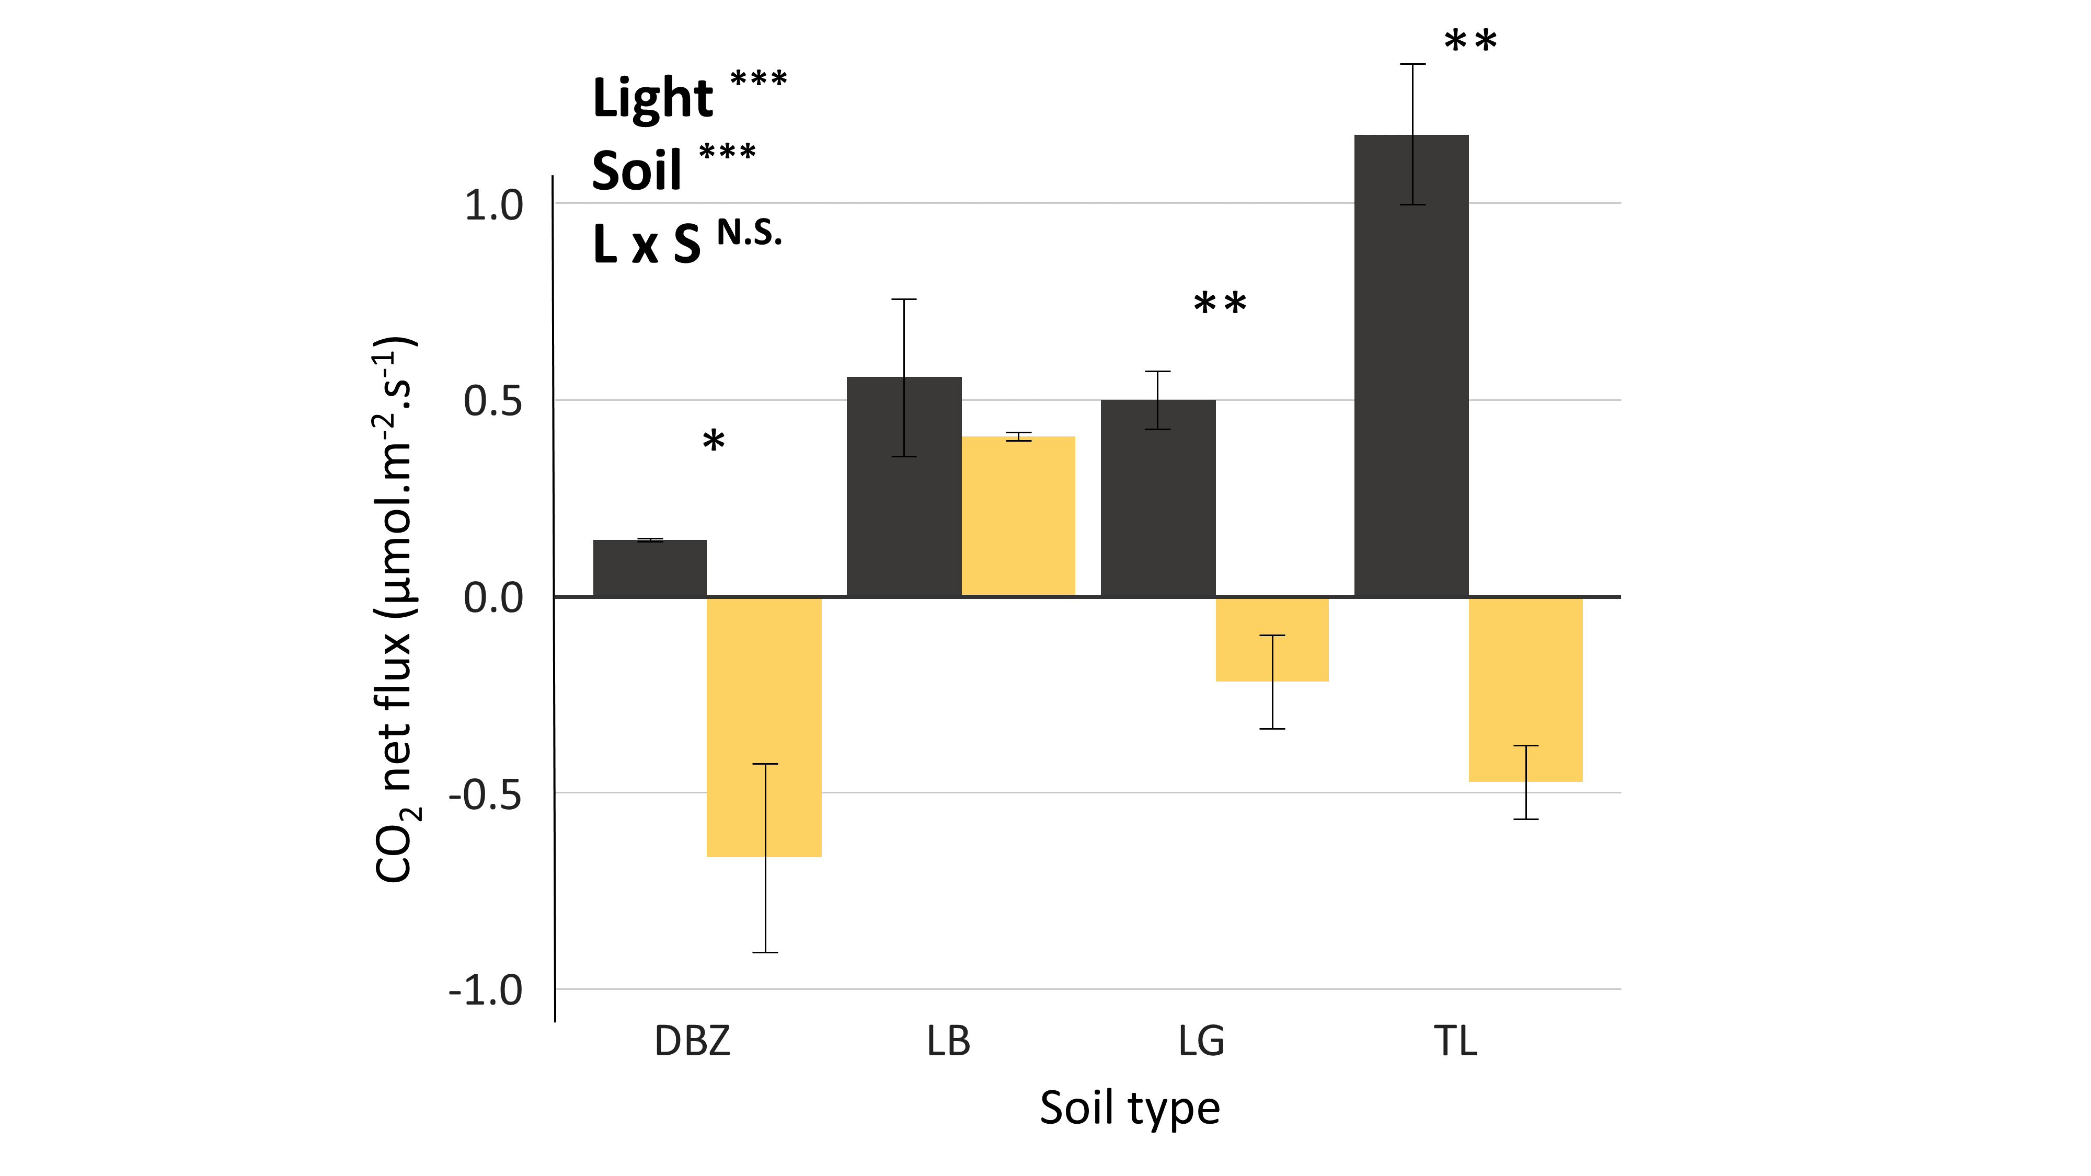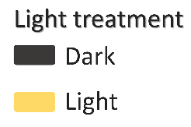The four different soil types (i.e., DBZ, LB, LG and T) showed strong differences in soil pH and texture among treatments (Table 1). Soil pH ranged from 4.5 to 8.1, with the pine forest LB being the most acidic and the orchard TL the most basic, while the croplands LG and DBZ had intermediate ‘neutral’ pH values. DBZ and LB were very sandy compared with LG and TL soils that were mainly composed of silt and clay (Table 1). The C:N ratio of LB soils was twofold higher than that of LG and TL, while that of DBZ was intermediate (Table 1).

**Figure 1** – a) Microcosm CO2 and b) COS net fluxes across different soil types and light treatments

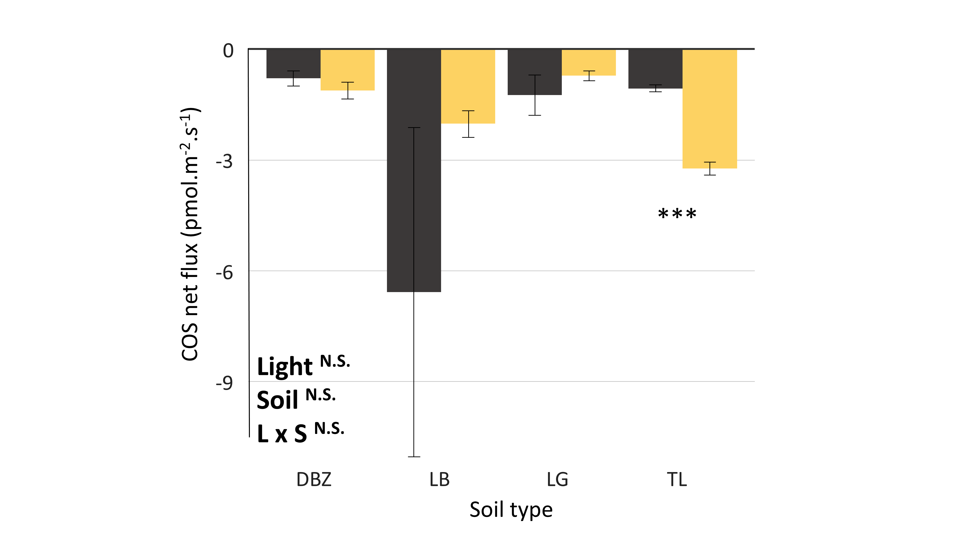

## COS and CO2 balance across soil types and light treatments

Soils were always sources of CO2 in the dark and sinks in the light, except for the LB soil that continued acting as a source even when exposed to light (Fig. 1a). This resulted in significant differences between dark and light treatments for all soils, except for LB. When it came to COS, all soils acted as sinks (Fig. 1b). TL was the only soil that showed a significant difference in COS flux between light and dark conditions.

## Effect of soil types and light treatments on microbial communities

Soil type and light treatment, as well as their interaction had significant effects on phototroph communities (Appendix 1, Table 2). When looking at the different classes, we found that LB soils appeared very dissimilar compared with the three other soil types (*p* < 0.001). Indeed, phototroph communities in this soil did not include common classes observed in the other soils such as *Bacillariophyceae* or *Dinophyceae*. On the other hand, the LB soil was the only soil that presented a relatively high abundance of *Zygnemophyceae* among all soil types. When investigating the effect of light, we found that this effect was particularly important in DBZ and LB soils. Regarding the DBZ soil, most OTUs belonging to *Trebouxiophyceae*, *Bacillariophyceae* and *Chlorophyceae* increased in the light conditions. However, 75% of classes in the dark in the DBZ soil were unidentified. A look at the phylum level revealed that most of the unidentified OTUs belonged to cyanobacteria. For the LB soils, we found a strong dominance of *Chlorophyceae* in the dark that accounted for more than 80% of the relative abundance. Zooming in the taxonomic levels revealed that they all belonged to the *Chlamydomonaceae* family. Interestingly we found that *Zygnemophyceae*increased significantly in the light treatment (Fig. 2a). Contrary to DBZ and LB soils, we found that the LG soil presented no differences when comparing between light to dark treatments (*p* = 0.43). Regarding TL, we found that this soil harboured a high relative abundance of *Bryopsida* both in light and dark treatments (Fig. 2a). Moreover, it is interesting to notice that *Chlorophyceae* relative abundance increased from light to dark in the LG soil, while it decreased in the TL soil. Finally, it is important to note that *Trebouxiophyceae* seems to thrive better in light environments, but that this class was present only in DBZ and TL soils.

Similar to phototroph communities, we found that soil type and light treatment, as well as their interaction had significant effects on bacterial communities (Appendix 1, Table 2). The LB soil was once again the most dissimilar one compared with the other soil types (Fig. 2b). In particular, the LB soil showed an important relative abundance of *Actinobacteria*, while DBZ, LG or TL did not. Regarding the light effect, we found that *Gammaproteobacteria* decreased in higher relative abundance when going in the light, but only in DBZ and TL soils. In contrast, there was a higher relative abundance of *Thermoprotei* in the light for these two soils compared with the dark treatment. *Actinobacteria* were also more abundant in the light than in the dark for DBZ and LG soils. Apart from that, all four soil types presented relatively similar bacterial communities, composed mostly of *Alphaproteobacteria*, *Gammaproteobacteria*, *Planctomycetatia*, *Sphyngobacteriia* and *Thermoprotei*.

Finally, we also found significant effects of soil, light and their interaction on fungal communities (Fig. 2c). Briefly, the LB soil appeared once again extremely different to DBZ, LG and TL. It displayed high relative abundance of *Leotiomycetes*, accounting for approximatively a fourth of the community, while the other soils presented a relatively low abundance of *Leotiomycetes*. The DBZ soil also had a singular community. First, it showed higher quantities of *Sordariomycetes* than the other soils. Then, the DBZ soil harbored many *Monoblepharidomycetes*, a class that could not be found elsewhere in such quantity. Regarding the light effect, we foundthat *Monoblepharidomycetes* had a significantly higher relative abundance in the dark than in the light for the DBZ soil**.** It also appeared that the relative abundance of *Sordariomycetes* increased from dark to light in DBZ and TL soils. Finally, LG and TL soils had relatively similar communities, mostly composed of *Agariomycocetes*, *Sordariomycetes* and *Dothideomycetes*, that are common classes present in all four soils. LG and TL were also the two soils with the higher relative abundance of unidentified OTUs.

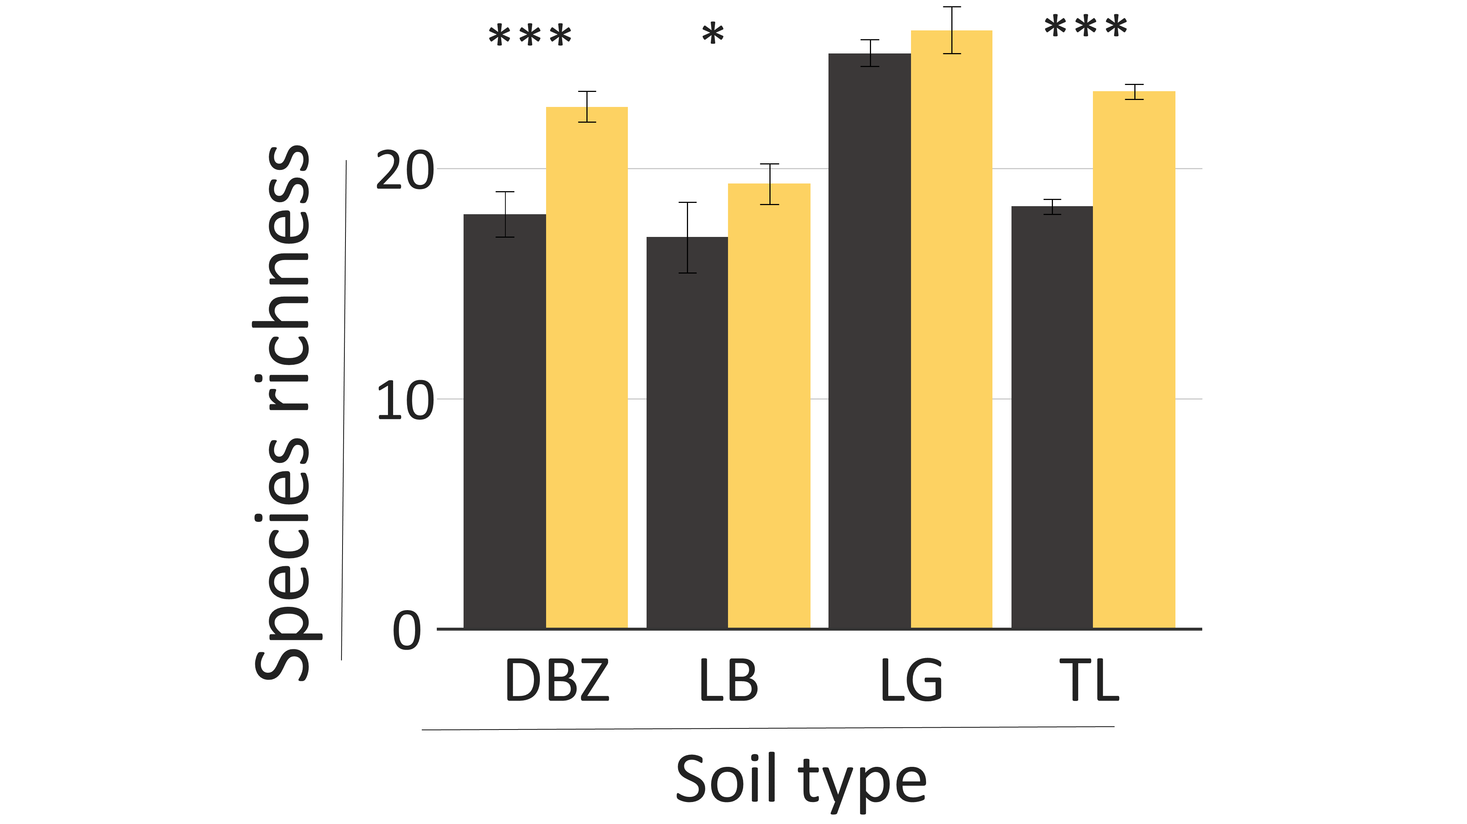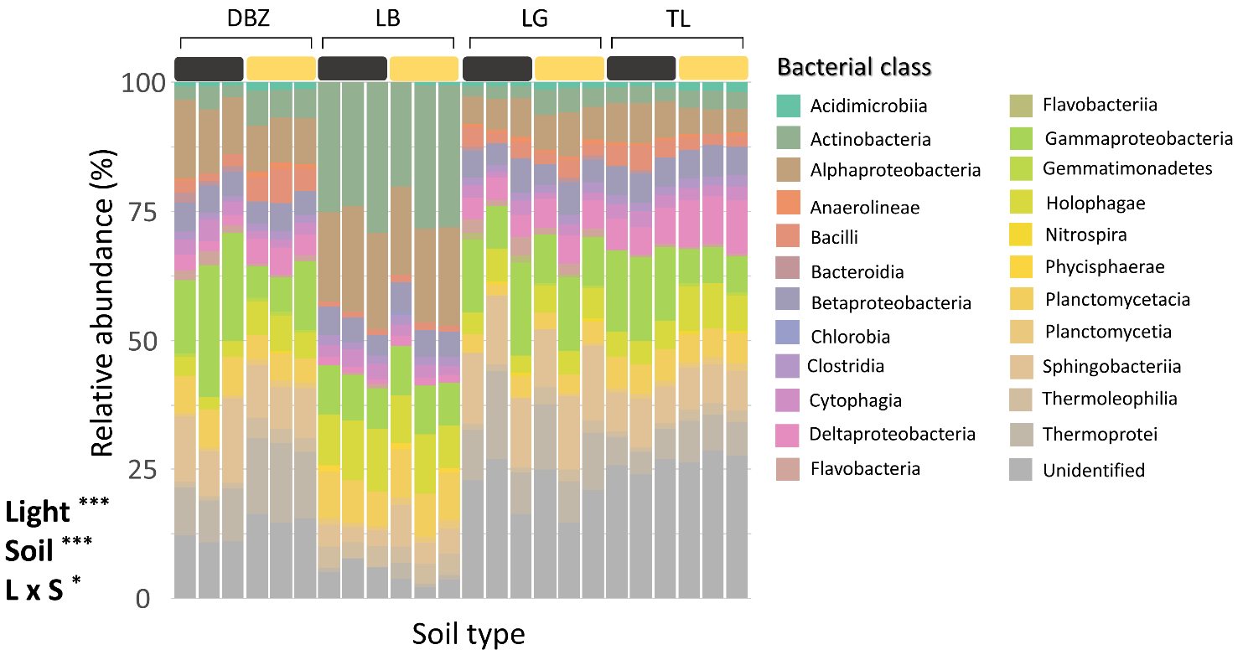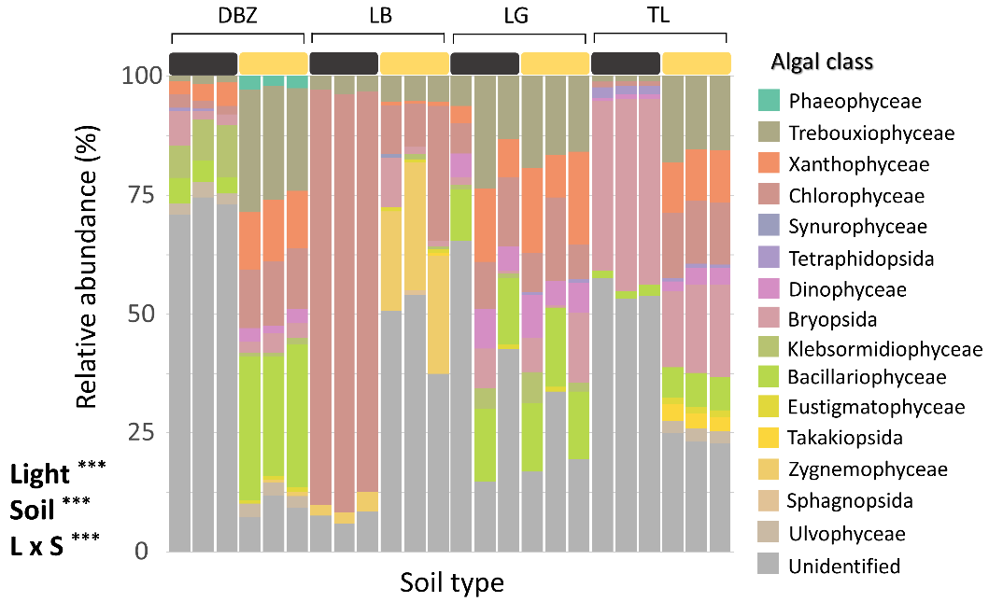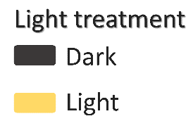

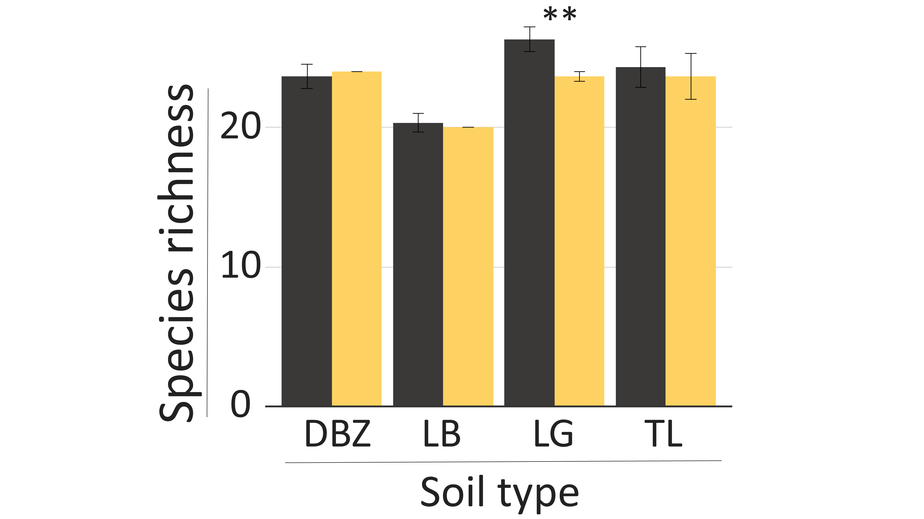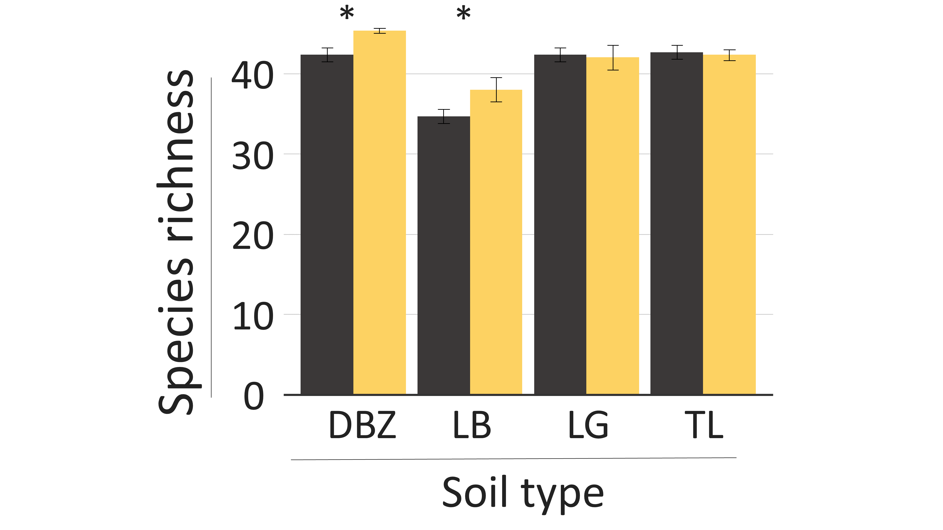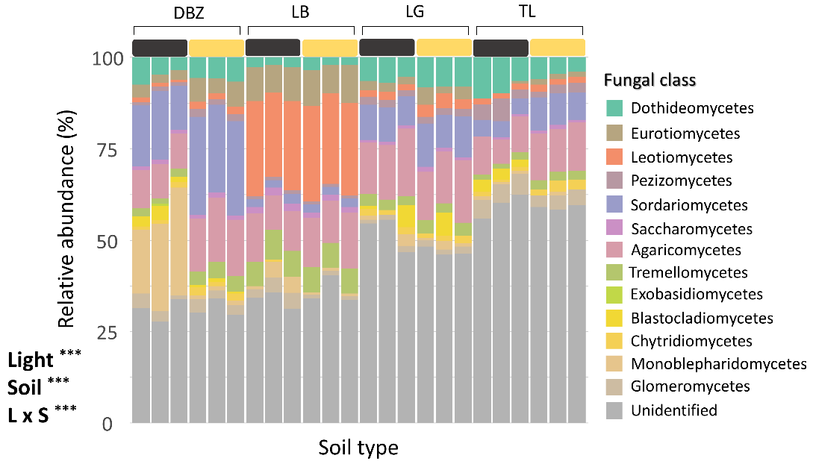

**Figure 2** - Community compositions and species richness for a,d) algae, b,e) bacteria and c,f) fungi across the different soil types and light treatments,

## Linking microbial communities to COS fluxes and soil physicochemical properties

We then performed canonical-correlation analysis (CCA) for each three groups. For the phototrophs, the variation was explained, first, by the horizontal axis dominated by soil parameters such as pH or granulometry, and then, by the vertical axis controlled by light conditions (Fig. 3a). The LB soil was clearly discriminated from LG and TL soils along the first CCA axis, mainly due to important differences in their physico-chemical properties (notably sand content and pH; Table 1). Light explained only a little portion of variation for LB and LG soils compared to the effect of soil properties. Indeed, both light and dark treatments for these two soils were gathered, but varied at both extreme along the horizontal axis. However, it is the exact opposite for DBZ and TL soils (Fig. 3a). In fact, both of these soils had their light and dark treatments separated along the second axis but were located at the same spot on the horizontal axis, therefore suggesting that the effect of light was more important than the effect of soil. COS uptake pointed in the direction of LB and was associated with *Oedipodiopsida, Polytrichopsida, Sphagnopsida, Zygnemophyceae, Takakiopsida* and *Mamiellophyceae***.**

For the bacteria, we found completely different results (Fig. 3b). Light had only a small effect on bacterial communities at the class level. Light and dark treatments were indeed often mixed, except for the DBZ soil. The LB soil was clearly discriminated from the other soils along the first CCA axis, while DBZ was at the opposite direction of TL along the second axis. On the other hand, TL and LG soils were grouped together toward the silt content and pH gradients. Therefore, it seemed that bacterial variations were mainly explained by soil properties through both axes, rather than by light. COS uptake pointed in the direction of LB soils and was associated to *Rubrobacteria, Erysipelotrichi, Solibacteres* and *Methanomicrobia***.**

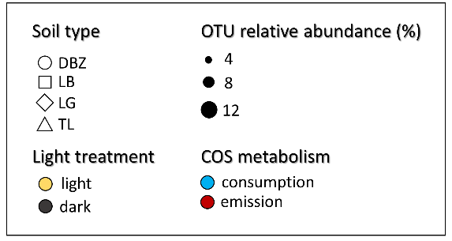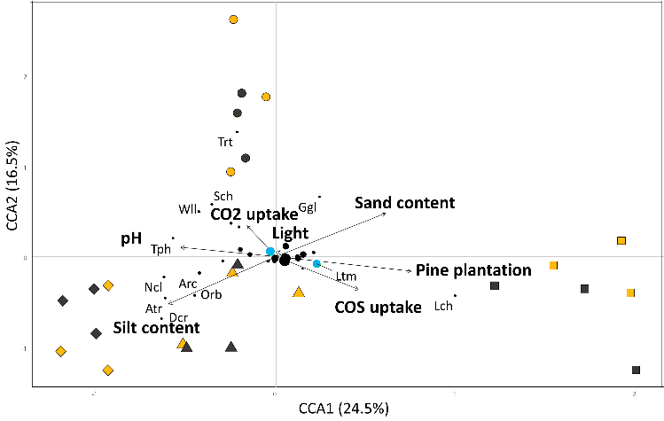**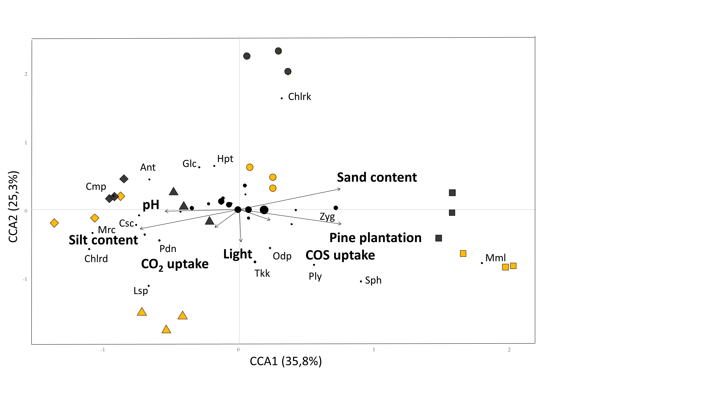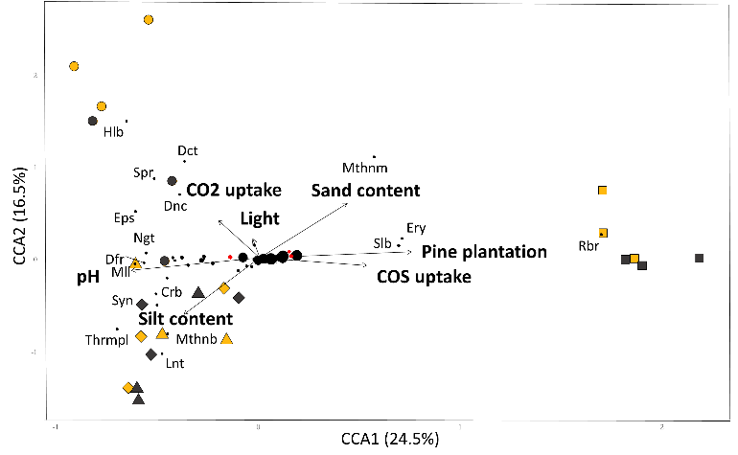Finally, for fungi, we found relatively similar patterns to those of bacteria (Fig. 3c). LB and DBZ soils remained isolated along the second and first axis, respectively, while LG and TL soils were grouped in the direction of pH and silt content. Since light and dark treatments appeared mixed on the plot, soil property gradients were the main source of variations in fungal communities. COS uptake pointed in the direction of LB soils and was associated to*Leotiomycetes* and *Lichinomycetes***.**

**Figure 3** – Canonical-correlation analysis for a) algae, b) bacteria and c) fungi communities. Relative abundance is based on the four soil types together. Points in green correspond to microbial classes identified as common COS uptakers in the litterature, while points in red corresponds to classes identified as COS producers.

## Effect of microbial OTUs on COS balance

Abundances of phototrophs, bacterial and fungal classes were compared with measured gas fluxes in either light or dark conditions to unveil potential correlations. Looking first at the phototrophs (Fig. 4a-4b), it appeared that only two classes correlated with COS uptake: unclassified phototrophs in the dark, and *Takakiopsida* in the light. When looking at potential COS emissions, a greater number of phototrophic classes presented a correlation with COS in the light treatment (11 against 7). On top of that, the 7 classes that correlated with emission in the dark were also found in the light, resulting in 4 exclusive classes that were only present in the light treatment: *Chrysophyceae*, *Trebouxiophyceae*, *Coscinodiscophyceae* and *Ulvophyceae*.

For bacteria (Fig. 4c-4d), many classes were associated with COS emission, but also with COS uptake, accounting for a greater number of correlations compared with phototrophs. The main bacterial classes associated with COS uptake in the dark were *Solibacteres* and *Chlorobia*, while *Actinobacteria*, *Planctomycetia* and *Planctomycetacia* were the most correlated to COS uptake in the light. *Phycisphaerae* correlated with COS uptake both in light and dark. A greater proportion of bacterial classes were also associated with COS emission, regardless of light treatment. *Flavobacteriia*, *Thermomicrobia*, *Anaerolinae* and *Caldilinae* were the most important classes in both treatments. *Thermoprotei* and *Flavobacteria* classes were also well correlated with COS emission but only in the light.

****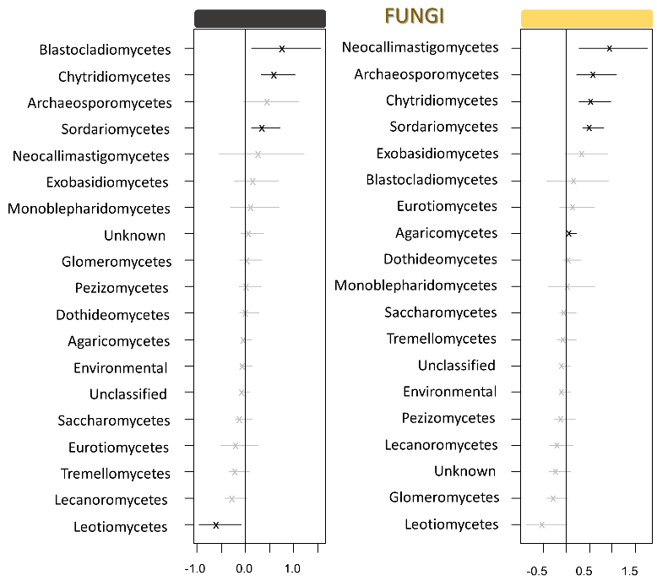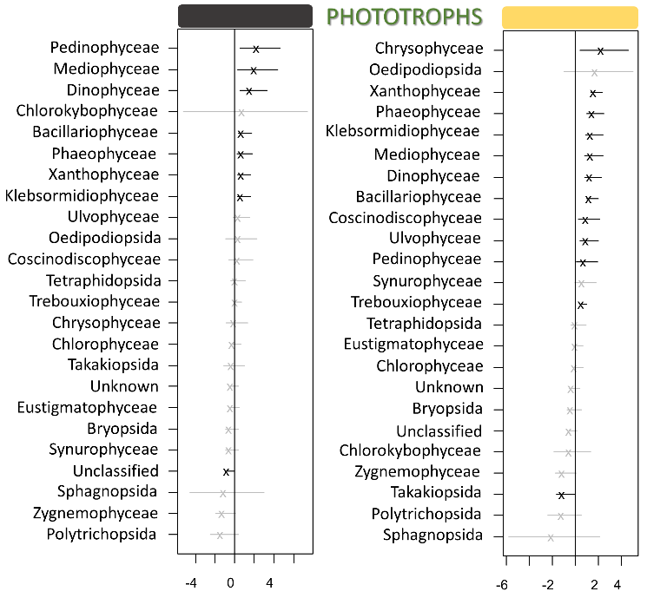Finally, fewer fungi than bacteria were identified as having a role in COS fluxes (Fig. 4e-4f). A single class was associated with COS uptake both in light and dark, the *Leotiomycetes*. *Chytridiomycetes* and *Sordariomycetes* were correlated with COS emission in both light and dark treatments, while *Blastocladiomycetes* only correlated in the dark treatment. A few other classes were associated to COS emission only in the light, such as *Neocallimastigomycetes*, *Archaeosporomycetes* and *Exobasidiomycetes*.

## 

**Figure 4** – Generalized latent linear variable model focused on the impact of a-b) algae, c-d) bacteria and e-f) fungi classes on COS emission or uptake in the dark (left) and in the light (right). A negative number implies a correlation with COS uptake and vice versa.

## Microbial interactions network

**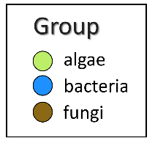*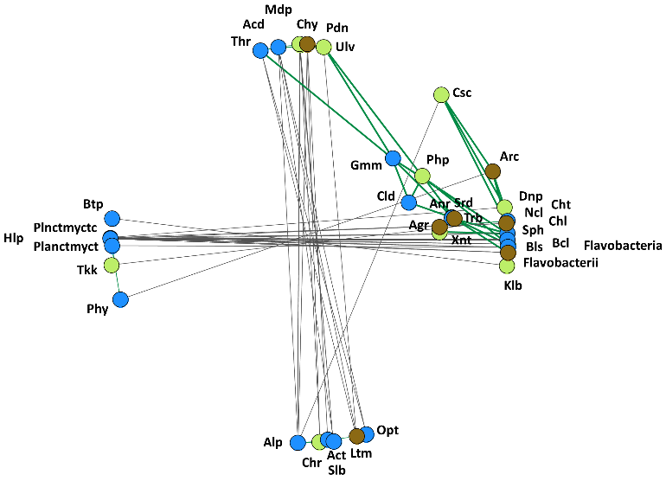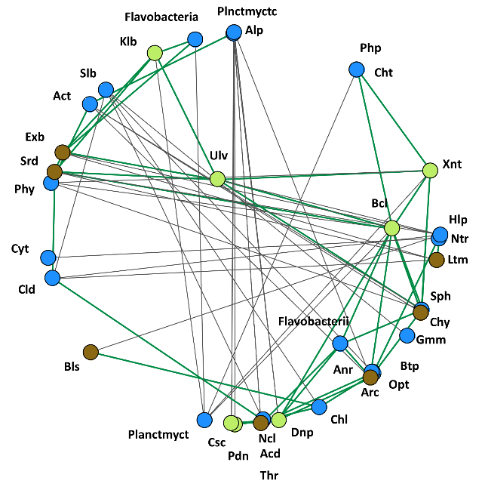***

**Figure 5** – Network analysis focused on phototroph, bacterial and fungal classes that showed associations with COS or CO2 uptake or emission. Green and gray lines display positive and negative associations, respectively. Networks were built according to microbial abundances a) in the dark and b) in the light.

Network analyses were carried out in order to visualize potential interactions, either in the light or in the dark, between the microbes involved in COS fluxes. When observed in the dark, it appeared that microbial communities were represented by several small clusters (Fig. 5a). First off, it is interesting to notice that the different phototroph classes did not present any negative associations with one another. As such, most of them were located to the outer right side of the figure, and displayed positive associations, not only with other phototrophs, but also with a wide range of fungi and bacteria, such as *Neocallimastigomycetes* (Ncl), *Chytridiomycetes* (Chy), *Sphingobacteriaa* (Sph) and *Betaproteobacteria* (Btp). Two bacterial classes located to the top of the figure, *Planctomycetacia* (Plnctmyctc) and *Alphaproteobacteria* (Alp) displayed negative associations with *Pedinophyceae* (Pdn), *Coscinodiscophyceae* (Csc) and *Dinophyceae* (Dnp), three algal classes. On the other hand, the algal class *Ulvophyceae* (Ulv), centered around the middle of the figure, displayed positive associations with other phototrophic classes, but also with two fungi, *Sordariomycetes* (Srd) and *Exobasidiomycetes* (Exb).

When observed in the light, soil microbial communities displayed even more clustered association patterns (avgCC of 0.58 in the light compared to 0.45 in the dark). Four main clusters were displayed, and they each presented negative associations with opposing clusters located on the other side of the figure. While bacteria were predominant on the bottom and left of the figure, most algae classes were concentrated toward the upper and right side and displayed many positive associations with other fungi and bacteria, such as *Chytridiomycetes* (Chy), *Sordariomycetes* (Srd) and *Gemmatimonadetes* (Gmm). On the other hand, *Leotiomycetes* (Ltm)and *Chrysophyceae* (Chr)*,* two classes that were strongly correlated with COS fluxes in the light, were positioned on the bottom of the figure, an area dominated by bacteria. As such, these two classes were negatively associated with *Pedinophyceae* (Pdn), *Ulvophyceae* (Ulv) and *Chytridiomycetes* (Chy).

# Discussion :

By implementing a soil incubation and gas measurement experiment coupled with the use of high-throughput sequencing tools, we explored the effects of soil type, light and their interaction on microbial community composition, as well as its regulative role on COS fluxes. We tested three hypotheses: phototroph community composition would change in light-conditions compared with dark-conditions (H1), these changes would influence heterotrophic microbial composition in return (H2) and specific microbial classes would be linked to variations in COS fluxes (H3). Our results supported all three hypotheses, hence demonstrating that light can have both direct (on phototrophs) and indirect effects (on bacteria and fungi) on soil microbial communities.

## Effect of light on photoautotroph community composition

In accordance with our first hypothesis, light had a significant effect on photoautotroph community composition in all soil types (Appendix 1, Table 2). However, the weight of this effect varied across soil types (Fig. 3a) and, as such, light was shown as the dominant factor in only two soils out of four (DBZ and TL). In these two soils, we found an increase in the relative abundance of *Trebouxiophyceae*, *Xanthophyceae*, *Chlorophyceae* and *Bacillariophyceae* (i.e., diatoms) with light, as together they accounted for more than 75% of the communities in term of estimated relative abundance. These classes all heavily rely on light as a source of energy, and therefore directly benefited from the soil incubation in the light. On the other hand, it appeared that the development of these four classes was made at the expense of cyanobacterial classes that were relatively more dominant in the dark. Although the cyanobacterial phylum is most commonly associated with the ability to photosynthesise (the oxyphotobacteria), there are two non-photosynthetic classes (*Melainabacteria* and *Sericytochromatia*) with diverse metabolisms and the potential to survive mixtrophically (Cano-Díaz et al., 2019; Soo et al., 2017; Subashchandrabose et al., 2013). Unfortunately, the μgreen and Dijon database did not contain matching sequences for the cyanobacteria identified in our soils, with the parameters selected. As such, we were not able to have the resolution needed to go down the phylum level, even though our study clearly suggests that light impacted the cyanobacteria present in microbial communities. The next step would then be to improve the pipeline, in order to be able to continue to explore and understand functional changes of cyanobacteria in soils.

In LB and LG soils, most of the variability observed in terms of community structure was attributed to the soil physicochemical properties (Fig. 3a). For instance, xx and yy. As such, light did not have a significant effect on the phototroph community composition in LG soils (*p* = 0.43). However, even though soil properties were the most important drivers of community composition, we found that the community composition of LB differed significantly between dark and light. Although LB communities were strongly dominated by *Chlorophyceae* in the dark, we were able to observe more diverse communities in light conditions that included *Zygnemophyceae*, an algae class only observed at this level of abundance in LB soils. This observation might be explained by either a tolerance of this class to grow in soils with low pH values, and/or by the possibility that most algal classes in competition with *Zygnemophyceae* cannot sustain the acid conditions (Lund, 1947), therefore allowing this specific class to bloom only in LB. Overall, it appeared that almost all photoautotrophic communities reacted significantly to light, but that the induced shifts followed different patterns in accordance with soil type.

## Effect of photoautotroph community composition on heterotroph communities

In line with our second hypothesis, shifts in photoautotrophic community composition influenced heterotrophic communities in several ways. In the light, the abundance of fungal OTUs from the *Chytridiomycetes* class were positively correlated with the abundance of the algal class *Ulvophyceae* that was also greatly favoured in light conditions (Fig. 5b). This observation might suggest that fungal classes such as *Chytridiomycetes,* known for their parasitic behavior of algae (Ibelings et al., 2004), may have benefitted from the light-induced development of photoautotrophs, in this case *Ulvophyceae*. In a recent study from Sauze et al. (2017) conducted on the same soils, despite fungal preference for slightly acidic soils, relatively higher numbers of fungal gene copies were also observed in alkaline soils, but only in the presence of increased phototrophs. Moreover, copiotrophic organisms such as OTUs from the bacterial classes *Sphingobacteria* or *Flavobacteria* (both belonging to the *Bacteroidetes* phylum) appeared correlated to many algal OTUs belonging to *Bacillariophyceae*, *Dinophyceae* and *Klebsormidiophyceae* (Fig. 5b). This result is especially interesting, as it suggests the relevance of a parallel for the concept of phycosphere between marine and terrestrial ecosystems. Indeed, heterotrophic organisms might not only benefit from the proximity of photoautotrophs through interactions with higher plants in the rhizosphere, but also from interacting with free-roaming photoautotrophic microorganisms. However, in contrast with the copiotroph-oligotroph model, bacteria considered as copiotrophic such as the classes belonging to *Proteobacteria* (Sauvadet et al., 2019) did not appear to be associated with any algal classes in the light (Fig. 5b)**.** In addition to that, *Alphaproteobacteria*, a class of *Proteobacteria* usually classified among copiotrophic organisms, even appeared negatively correlated with *Coscinodiscophyceae*, a class of diatoms that positively correlated with other copiotrophic bacteria (Fig. 5b). In the light of these results, it is important to bear in mind that a growing body of literature points out that the investigation of the copiotroph-oligotroph model at high taxonomic levels has inherent limitations, and that it is often preferable to explore these relationships at finer levels (Ho et al., 2017; Sauvadet et al., 2019).

## Links between microbial OTUs and COS fluxes

According to our GLLVM analyses, many microbial classes (i.e., phototrophs, bacteria, fungi) displayed correlations with COS fluxes either in the light and/or dark. However, no photoautotroph classes appeared correlated significantly with COS uptake in the dark (Fig. 4a). Taxa belonging to *Takakiopsida*, a class of primitive mosses, were the only phototrophs to correlate with COS uptake in the light. On the other hand, most phototroph classes were surprisingly associated with COS emission both in light and dark. This result is not consistent with the current knowledge on algae, that are mostly identified as COS consumers (Protoschill-Krebs et al., 1995; Gries et al., 1994; Blezinger et al., 2000). Regarding bacteria, the association of the different classes with the emission or consumption of COS depended only marginally on the light treatment. Several classes, like *Actinobacteria* or *Phycisphaerae*, appeared correlated with COS uptake both in light and dark conditions (Fig. 4d). Zooming in the taxonomic levels, *Actinomycetes* is one of the most studied order of *Actinobacteria* and has already shown intense COS consumption in the literature (Ogawa et al., 2016). On the other hand, many other bacterial classes displayed correlation with COS emission, including *Gemmatimonadetes* that has already been identified as a class including COS emitters (Meredith et al., 2018). Finally, regarding fungi, *Mortierellomycetes* did not display a correlation with COS emission in the study (Fig. 4e,f), contrary to results in other studies (Kitz et al., 2019; Masaki et al., 2016). In addition, *Leotiomycetes* and *Sordariomycetes* were expected to display correlations with COS consumption based on findings in the literature (Meredith et al., 2018; Whelan et al., 2018). However, while *Leotiomycetes* was associated with COS uptake both in the light and dark (Fig. 4e,f), *Sordariomycetes* were associated with COS emission in our study. Currently, no experiments have demonstrated that *Sordariomycetes* are COS emitters. All these results provide insights to explain the balance of COS fluxes in the different soil types. LB soils in the dark were the most important COS sinks across all soil types and light treatments (Fig. 1b). This was particularly consistent with the composition of the communities found within the LB soils, which harboured both bacteria of the *Actinobacteria* class and fungi of the *Leotiomycetes* class, both of which are potent consumers of COS. Second, TL soils under light represented much more efficient COS sinks than in the dark, notably due to . Moving from the dark treatment to light led to a significant shift in phototrophic community composition, including an increase in the relative abundance of the *Takakiopsida* class. Although this class remains a minority within phototrophic communities, bryophytes are known to be powerful consumers of COS (Gimeno et al., 2017).

# Conclusion

The work carried out during this research project reveals that light, through its effect on phototrophic organisms, affects soil microbial communities altogether. We found that these light-induced shifts in the composition and structure of soil microbial communities followed different patterns depending on the physicochemical parameters of the soils, with pH and particle size being the two main drivers within this category. Our results are in agreement with our first hypothesis about light shaping phototroph communities, as light significantly influenced phototroph community composition in all soil types. The results also support our second hypothesis that shifts in phototrophic communities influence in turn heterotrophic communities. Many classes of bacteria and fungi, either known as potential parasites or predators of algae, or others for their high capacity to exploit the resources of their environment (i.e. copiotrophic organisms), have shown correlations between their abundance and that of algae favoured by light. Finally, our third hypothesis is partially validated, since we were able to observe many links between COS fluxes and microbial classes. Some of these observations were consistent with the current literature on the subject, while others were not. As such, in order to further explore the effects of environmental drivers on COS fluxes related to soil microbial communities, the next step would be to improve existing pipelines for a better characterization of these communities. This would allow the efficient attribution of function at more precise taxonomic levels, thus allowing the observation of potential interactions that have remained hidden until now, and to define more precisely the role of the different actors within the soil phycosphere.

# References

Berry, J., Wolf, A., Campbell, J. E., Baker, I., Blake, N., Blake, D., … Zhu, Z. (2013). A coupled model of the global cycles of carbonyl sulfide and CO2: A possible new window on the carbon cycle. *Journal of Geophysical Research: Biogeosciences*, *118*(2), 842–852.

Blezinger, S., Wilhelm, C., & Kesselmeier, J. (2000). Enzymatic Consumption of Carbonyl Sulfide (COS) by Marine Algae. *Biogeochemistry*, *48*(2), 185–197. Retrieved from JSTOR.

Campbell, J., Carmichael, G., Chai, T., Mena-Carrasco, M., Tang, Y., Blake, D., … Stanier, C. (2008). Photosynthetic Control of Atmospheric Carbonyl Sulfide During the Growing Season. *Science (New York, N.Y.)*, *322*, 1085–1088.

Cano-Díaz, C., Maestre, F. T., Eldridge, D. J., Singh, B. K., Bardgett, R. D., Fierer, N., & Delgado-Baquerizo, M. (2019). *Ecological niche differentiation in soil cyanobacterial communities across the globe* [Preprint].

Djemiel, C., Plassard, D., Terrat, S., Crouzet, O., Sauze, J., Mondy, S., … Maron, P.-A. (2020). µgreen-db: a reference database for the 23S rRNA gene of eukaryotic plastids and cyanobacteria. *Scientific Reports*, *10*(1), 1–11.

Gimeno, T. E., Ogée, J., Royles, J., Gibon, Y., West, J. B., Burlett, R., … Wingate, L. (2017). Bryophyte gas-exchange dynamics along varying hydration status reveal a significant carbonyl sulphide (COS) sink in the dark and COS source in the light. *The New Phytologist*, *215*(3), 965–976.

Gries, C., Nash, T. H., & Kesselmeier, J. (1994). Exchange of reduced sulfur gases between lichens and the atmosphere. *Biogeochemistry*, *26*(1), 25–39. doi: 10.1007/BF02180402

Ho, A., Di Lonardo, D. P., & Bodelier, P. L. E. (2017). Revisiting life strategy concepts in environmental microbial ecology. *FEMS Microbiology Ecology*, *93*(3).

Ibelings, B. W., Bruin, A. D., Kagami, M., Rijkeboer, M., Brehm, M., & Donk, E. V. (2004). Host Parasite Interactions Between Freshwater Phytoplankton and Chytrid Fungi (chytridiomycota)1. *Journal of Phycology*, *40*(3), 437–453.

Kaiser, C., Kilburn, M. R., Clode, P. L., Fuchslueger, L., Koranda, M., Cliff, J. B., … Murphy, D. V. (2015). Exploring the transfer of recent plant photosynthates to soil microbes: mycorrhizal pathway vs direct root exudation. *The New Phytologist*, *205*(4), 1537–1551.

Kesselmeier, J., Teusch, N., & Kuhn, U. (1999). Controlling variables for the uptake of atmospheric carbonyl sulfide by soil. *Journal of Geophysical Research: Atmospheres*, *104*(D9)

Kitz, F., Gómez-Brandón, M., Eder, B., Etemadi, M., Spielmann, F. M., Hammerle, A., … Wohlfahrt, G. (2019). Soil carbonyl sulfide exchange in relation to microbial community composition: Insights from a managed grassland soil amendment experiment. *Soil Biology and Biochemistry*, *135*, 28–37.

Lund, J. W. G. (1947). Observations on Soil Algae II. Notes on Groups Other than Diatoms. *The New Phytologist*, *46*(1), 35–60. Retrieved from JSTOR.

Masaki, Y., Ozawa, R., Kageyama, K., & Katayama, Y. (2016). Degradation and emission of carbonyl sulfide, an atmospheric trace gas, by fungi isolated from forest soil. *FEMS Microbiology Letters*, *363*(18).

Meredith, L. K., Ogée, J., Boye, K., Singer, E., Wingate, L., von Sperber, C., … Welander, P. V. (2019). Soil exchange rates of COS and CO 18 O differ with the diversity of microbial communities and their carbonic anhydrase enzymes. *The ISME Journal*, *13*(2), 290–300.

Montzka, S. A., Calvert, P., Hall, B. D., Elkins, J. W., Conway, T. J., Tans, P. P., & Sweeney, C. (2007). On the global distribution, seasonality, and budget of atmospheric carbonyl sulfide (COS) and some similarities to CO2. *Journal of Geophysical Research: Atmospheres*, *112*(D9).

Ogawa, T., Kato, H., Higashide, M., Nishimiya, M., & Katayama, Y. (2016). Degradation of carbonyl sulfide by Actinomycetes and detection of clade D of β-class carbonic anhydrase. *FEMS Microbiology Letters*, *363*(19).

Ogawa, T., Noguchi, K., Saito, M., Nagahata, Y., Kato, H., Ohtaki, A., … Katayama, Y. (2013). Carbonyl sulfide hydrolase from Thiobacillus thioparus strain THI115 is one of the β-carbonic anhydrase family enzymes. *Journal of the American Chemical Society*, *135*(10), 3818–3825

Plassart, P., Terrat, S., Thomson, B., Griffiths, R., Dequiedt, S., Lelievre, M., … Ranjard, L. (2012). Evaluation of the ISO Standard 11063 DNA Extraction Procedure for Assessing Soil Microbial Abundance and Community Structure. *PLoS ONE*, *7*(9).

Protoschill‐Krebs, G., Wilhelm, C., & Kesselmeier, J. (1995). Consumption of Carbonyl Sulphide by Chlamydomonas reinhardtii with Different Activities of Carbonic Anhydrase (CA) Induced by Different CO2 Growing Regimes. *Botanica Acta*, *108*(5), 445–448.

Protoschill-Krebs, G., Wilhelm, C., & Kesselmeier, J. (1996). Consumption of carbonyl sulphide (COS) by higher plant carbonic anhydrase (CA). *Atmospheric Environment*, *30*(18)

Ramette, A. (2007). Multivariate analyses in microbial ecology. *FEMS Microbiology Ecology*, *62*(2), 142–160.

Rhee, G.-‐ull, & Gotham, I. J. (1981). The effect of environmental factors on phytoplankton growth: Light and the interactions of light with nitrate limitation1. *Limnology and Oceanography*, *26*(4), 649–659.

Sandalls, F. J., & Penkett, S. A. (1977). Measurements of carbonyl sulphide and carbon: Disulphide in the atmosphere. *Atmospheric Environment (1967)*, *11*(2), 197–199.

Sauvadet, M., Fanin, N., Chauvat, M., & Bertrand, I. (2019). Can the comparison of above- and below-ground litter decomposition improve our understanding of bacterial and fungal successions? *Soil Biology and Biochemistry*, *132*, 24–27. doi: 10.1016/j.soilbio.2019.01.022

Sauze, J., Ogée, J., Maron, P.-A., Crouzet, O., Nowak, V., Wohl, S., … Wingate, L. (2017). The interaction of soil phototrophs and fungi with pH and their impact on soil CO2, CO18O and OCS exchange. *Soil Biology and Biochemistry*, *115*, 371–382.

Seymour, J. R., Amin, S. A., Raina, J.-B., & Stocker, R. (2017). Zooming in on the phycosphere: the ecological interface for phytoplankton-bacteria relationships. *Nature Microbiology*, *2*, 17065.

Sherwood, A. R., & Presting, G. G. (2007). UNIVERSAL PRIMERS AMPLIFY A 23S rDNA PLASTID MARKER IN EUKARYOTIC ALGAE AND CYANOBACTERIA1. *Journal of Phycology*, *43*(3), 605–608.

Smith, K. S., Jakubzick, C., Whittam, T. S., & Ferry, J. G. (1999). Carbonic anhydrase is an ancient enzyme widespread in prokaryotes. *Proceedings of the National Academy of Sciences of the United States of America*, *96*(26), 15184–15189.

Soo, R. M., Hemp, J., Parks, D. H., Fischer, W. W., & Hugenholtz, P. (2017). On the origins of oxygenic photosynthesis and aerobic respiration in Cyanobacteria. *Science*, *355*(6332)

Subashchandrabose, S. R., Ramakrishnan, B., Megharaj, M., Venkateswarlu, K., & Naidu, R. (2013). Mixotrophic cyanobacteria and microalgae as distinctive biological agents for organic pollutant degradation. *Environment International*, *51*, 59–72.

Terrat, Sébastien, Christen, R., Dequiedt, S., Lelièvre, M., Nowak, V., Regnier, T., … Ranjard, L. (2012). Molecular biomass and MetaTaxogenomic assessment of soil microbial communities as influenced by soil DNA extraction procedure. *Microbial Biotechnology*, *5*(1), 135–141.

Terrat, Sebastien, Plassart, P., Bourgeois, E., Ferreira, S., Dequiedt, S., Adele‐Dit‐De‐Renseville, N., … Ranjard, L. (2015). Meta-barcoded evaluation of the ISO standard 11063 DNA extraction procedure to characterize soil bacterial and fungal community diversity and composition. *Microbial Biotechnology*, *8*(1), 131–142.

Whelan, M. E., Lennartz, S. T., Gimeno, T. E., Wehr, R., Wohlfahrt, G., Wang, Y., … Campbell, J. E. (2018). Reviews and syntheses: Carbonyl sulfide as a multi-scale tracer for carbon and water cycles. *Biogeosciences*, *15*(12), 3625–3657.

# Supplementary material

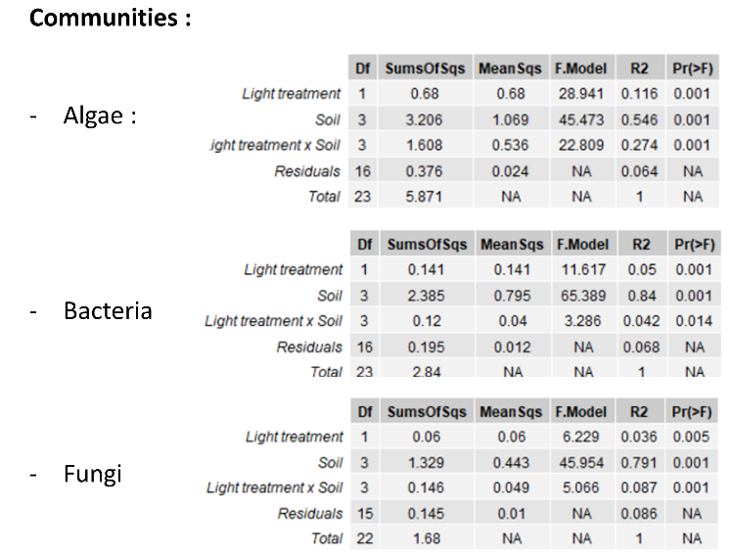

**Table 2** – Permanova analysis testing the significance of light treatment, soil type and the interaction of both, on algae, bacteria and fungi community composition at the genus level.

# Contributions

The hypotheses were formulated by Lisa Wingate (ISPA). The experimental design used during this internship was developed by Joana Sauze , Pierre-Alain Maron, Jérôme Ogée, Olivier Crouzet and Lisa Wingate. Soil collection was completed between December 2015 and April 2016 by Joana Sauze. Soil incubations and gas exchange experiments were carried out by Joana Sauze and Steven Wohl. Soil community analysis and bioinformatic pipeline development was performed by the INRAE team in Dijon composed of Pierre-Alain Maron, Virginie Nowak, Sébastian Terret, Christophe Djemiel, Damien Plassard, Samuel Mondy and Evert Van Schaik. Data formatting was completed by Clement Foucault (ISPA), in close consultation with Lisa Wingate and Nicolas Fanin (ISPA). Clement Foucault analysed the data, chose the results and drew the figures in close consultation with Nicolas Fanin and Lisa Wingate. Clement Foucault wrote the first draft of the manuscript with the help of Lisa Wingate and Nicolas Fanin, and received feedback on the writing during the course of the internship.

# Planning of Clement Foucault’s internship, starting on 2020, January 6th and ending on 2020, June 30th

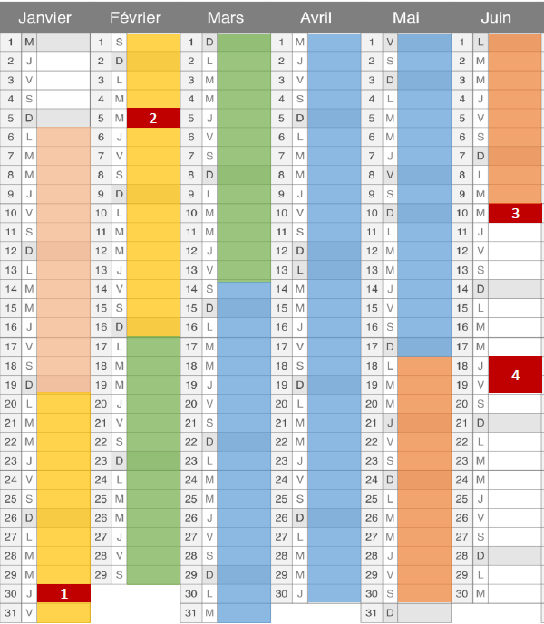

 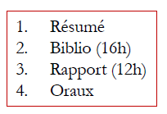

# Acknowledgments

I would like to thank my two supervisors, Lisa Wingate and Nicolas Fanin, first of all for accepting me into this research project, but also for their help, availability and valuable advices from which I was able to draw valuable experience about being a researcher. Despite the complicated sanitary conditions at the beginning of the year, they never stopped accompanying and supporting me, even from home. I would also like to thank the whole ECOFUN team for their great company and all those nice conversations we've been having over lunch. Finally, I would like to thank Koen Hufkens for lending me his desk while he’s gone, even though he probably doesn't know about it yet.

# Abstract

Soil microbes play a significant role in carbonyl sulphide (COS) fluxes within terrestrial ecosystems. Therefore, it is important to evaluate their contribution in order to use COS as a proxy for ecosystem gross primary production. Several parameters can affect soil COS fluxes, such as temperature, pH, moisture, and light. This study is focused on a better understanding of microbial diversity and activity in soil influenced by light, with a special spotlight on photoautotrophic organisms and how they shape microbial communities. Our goals were (1) to describe the effect of light on photoautotrophic community composition, (2) to assess whether shifts in phototroph community composition affect heterotrophic community composition, and (3) to evaluate whether changes in the composition of microbial communities would have important repercussions on soil COS fluxes. For the experiment, four soils with different physicochemical properties were sampled and incubated to stimulate the development of native soil phototrophs. Light treatments were applied to the soils, by incubating them either in light or dark. Microbial communities in these soils were looked at through metabarcoding analysis. We found that light systematically influenced the composition of phototrophic communities, and that these changes were potentially correlated with the development of bacteria and fungi that were either parasitic or able to benefit from an abundance of resources in their environment (i.e., copiotrophic organisms). Many classes of microbes were associated with COS fluxes, including some already mentioned in previous studies for their important role such as *Actinobacteria* or *Leotiomycetes*. We conclude that light has the potential to shape soil microbial communities and that this effect is not limited to phototrophic organisms, thereby influencing the regulation of COS fluxes in soils.